**Press Release**

**Media Contacts:**

**IB Communications**

Tel [+44 (0)20 89434685](tel:+44%20(0)20%2089434685)

[sekisui@ibcomms.agency](mailto:sekisui@ibcomms.agency)

**SEKISUI Completes £15.7 Million Expansion in cGMP Biopharma CDMO Capacity**

**Growth of UK facility will enable clinical-grade manufacturing of drug substances for range of biopharmaceutical products**

**Burlington, MA, USA – November 14, 2024** –SEKISUI Diagnostics’ microbial CDMO business announces it has completed construction of its £15.7 million ($20.7 million) cGMP capacity expansion at its UK site for clinical-grade drug substance manufacturing. Following appropriate licensure, this expansion will enable manufacturing capabilities for common drug types including enzymes, proteins and antibody fragment therapies, as well as plasmids and enzymes for cutting-edge gene therapy manufacture.

BioProduction by SEKISUI is SEKISUI Diagnostics’ contract service offering as a fermentation-focused CDMO with expertise in proteins and downstream purification. Their microbial process development and production experience helps smooth technical transfer and process scale-up. The new Grade C microbial fermentation and purification suites will accommodate production scales up to 1,000L.

“This investment supports the vision and mission of SEKISUI Diagnostics and the broader SEKISUI Medical Group by enabling the continued growth of our share of the biologics CDMO market,” said Robert Schruender, President & CE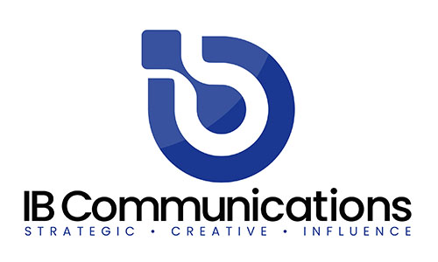O of SEKISUI Diagnostics. “We look forward to working with biopharma companies seeking an experienced partner at a time when demand is outstripping manufacturing capacity.”

Louise Digby, Vice President, Enzymes & BioProduction at SEKISUI Diagnostics added: “Over many years we have honed our technical and operational competency and expertise in enzyme production and microbial fermentation to serve our partners globally. This cGMP expansion enables us to support a broader customer base and expand our offering to existing customers.”

**About SEKISUI Diagnostics**

We are part of SEKISUI Medical Group with over 40 years of experience supplying innovative medical diagnostics globally to physicians, hospitals, laboratories and alternate testing locations.  Our product lines include clinical chemistry reagents, point-of-care tests, pre-analytic systems as well as enzymes, specialty biochemicals and the microbial CDMO business, BioProduction by SEKISUI.

**About SEKISUI Medical Group**

SEKISUI Medical Group is a diverse, global network consisting of a diagnostics business and pharmaceutical sciences business which spans drug development services and manufacturing, including active pharmaceutical ingredients and pharmaceutical intermediates, amino acids, as well as a wide range of enzymes for use in diagnostics, and biopharmaceutical contract manufacturing and more.